Creating a Public bucket in S3
This process explains how to create a bucket in Amazon S3 and configure its settings to allow public access. It includes steps like creating the bucket, uploading files, and adjusting permissions so that the content can be accessed by anyone using a link.
1.Dashboard
Go to the AWS Management Console and log in with your AWS account. After signing in, you will see the dashboard where all AWS services are accessible.

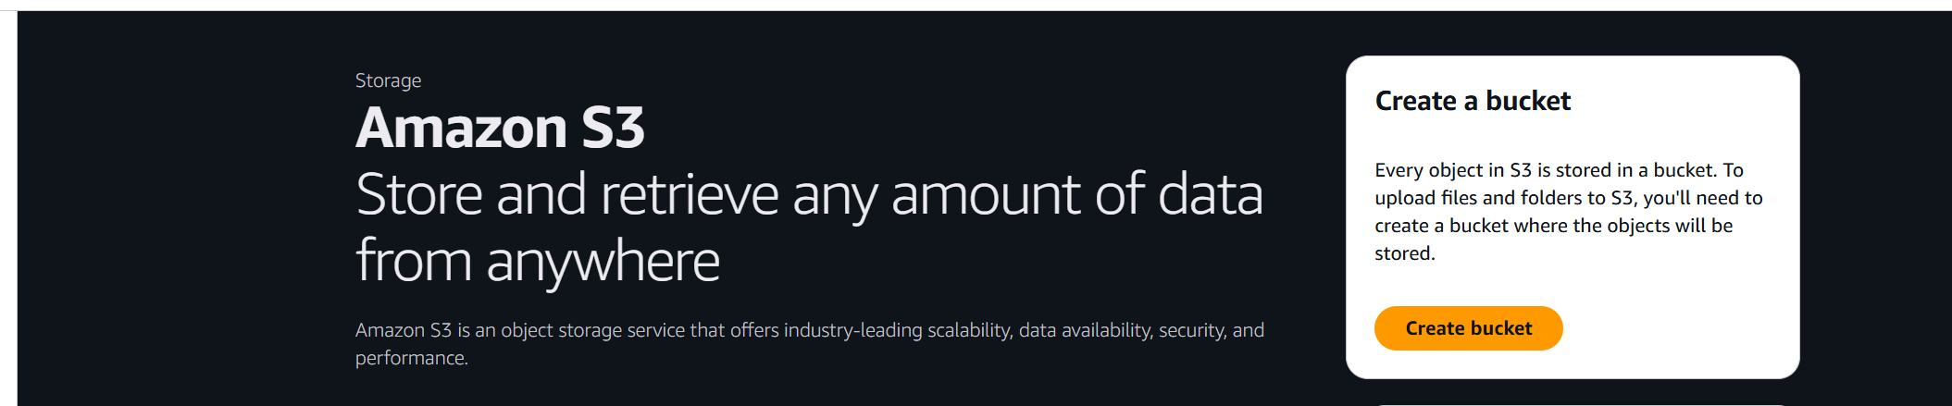

2. Creating a Bucket
PS that, ACL stands for Access Control List. In the Amazon S3 section of the AWS Management Console, click on “Create bucket.” Enter a unique bucket name, select a region, and update the settings as shown in the screenshots. Then click “Create bucket” to bucket.

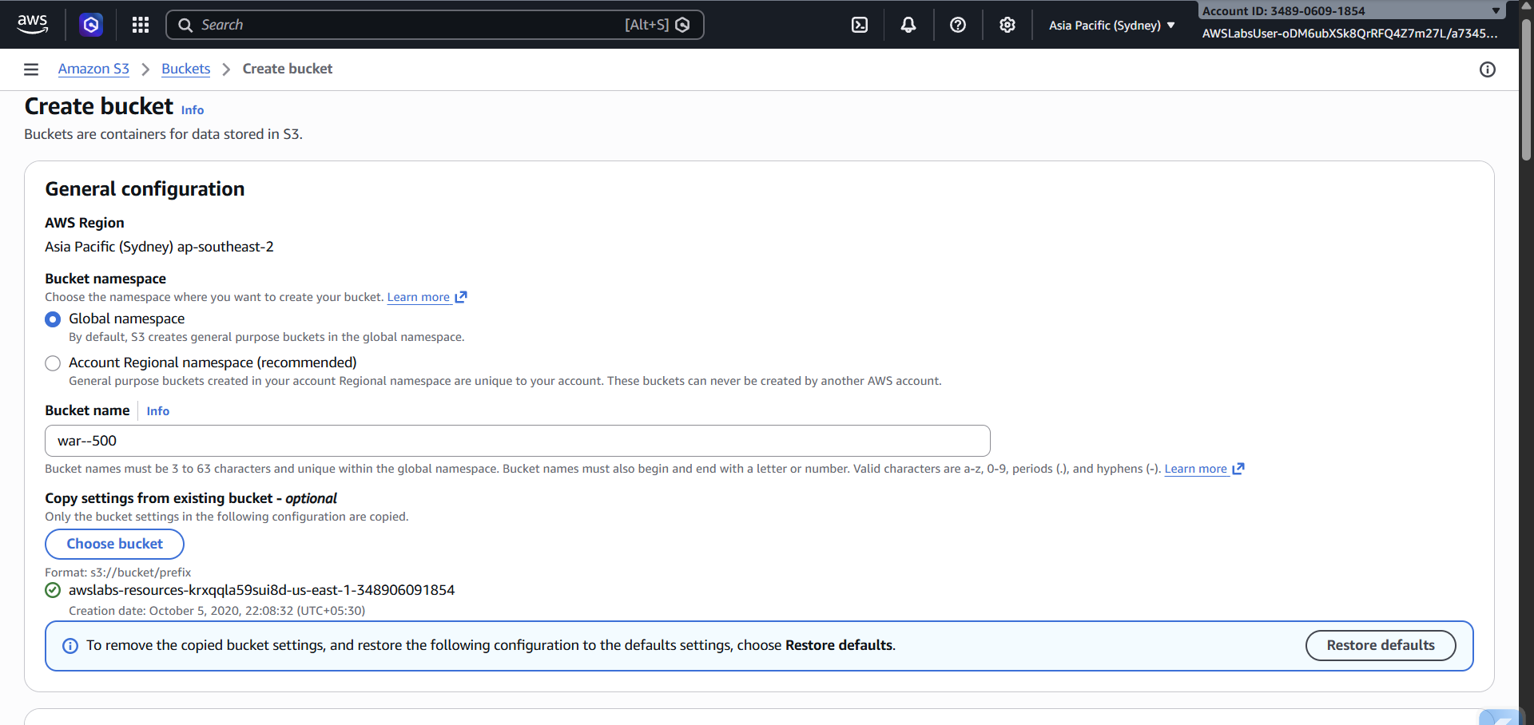
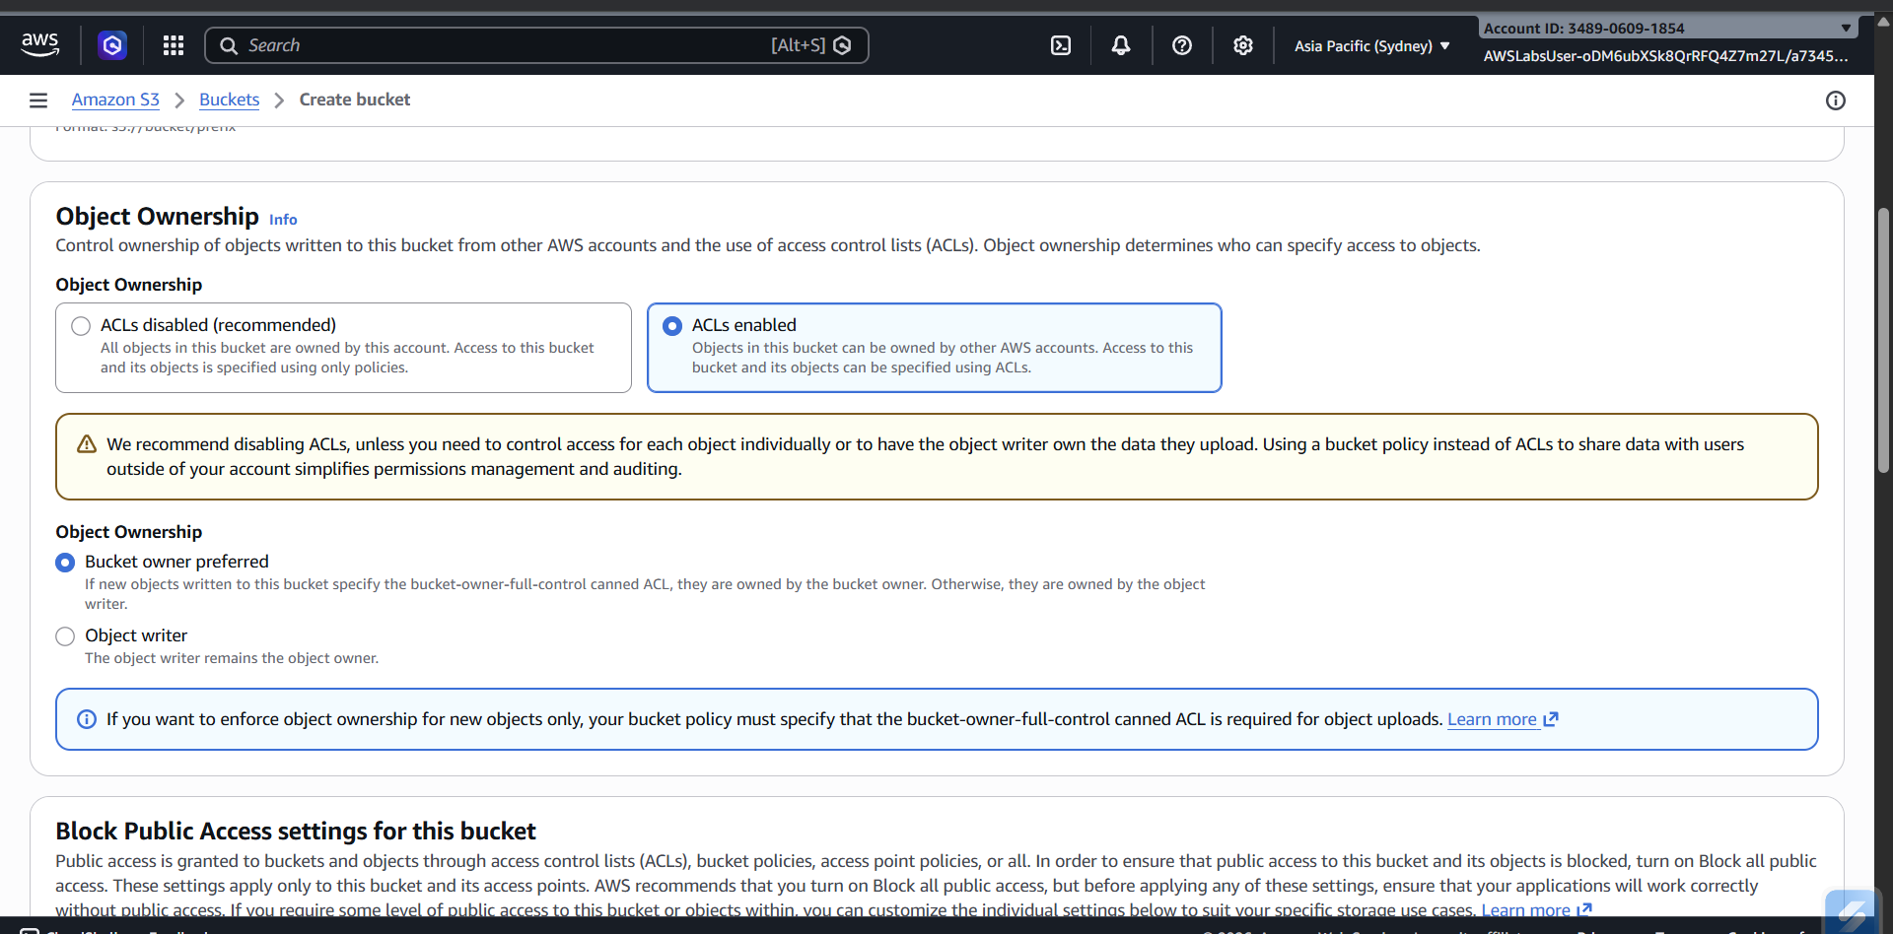

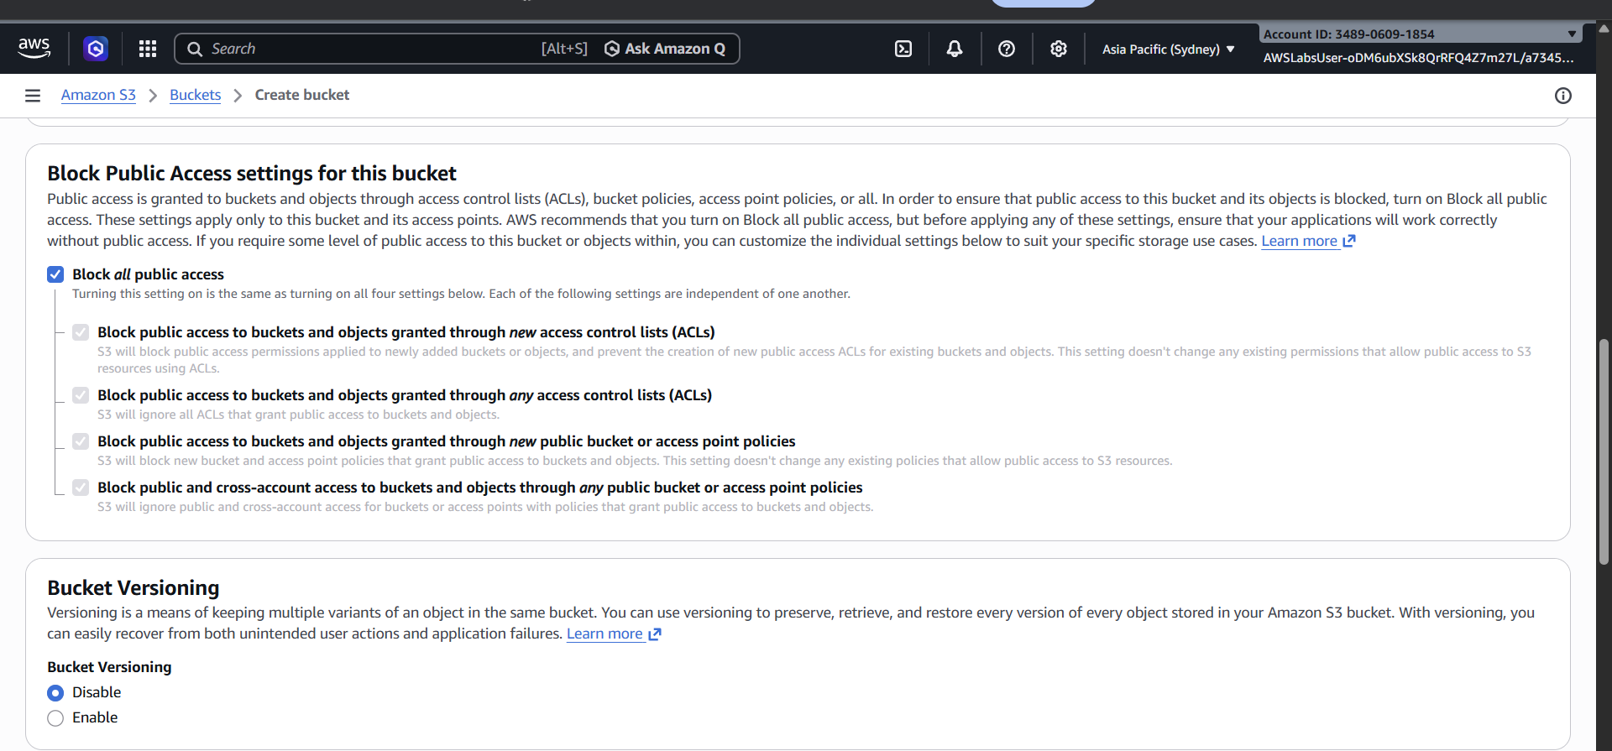

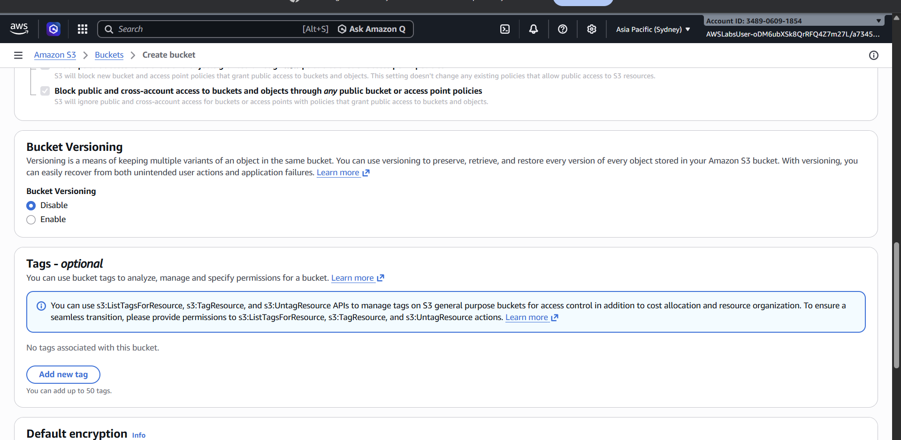

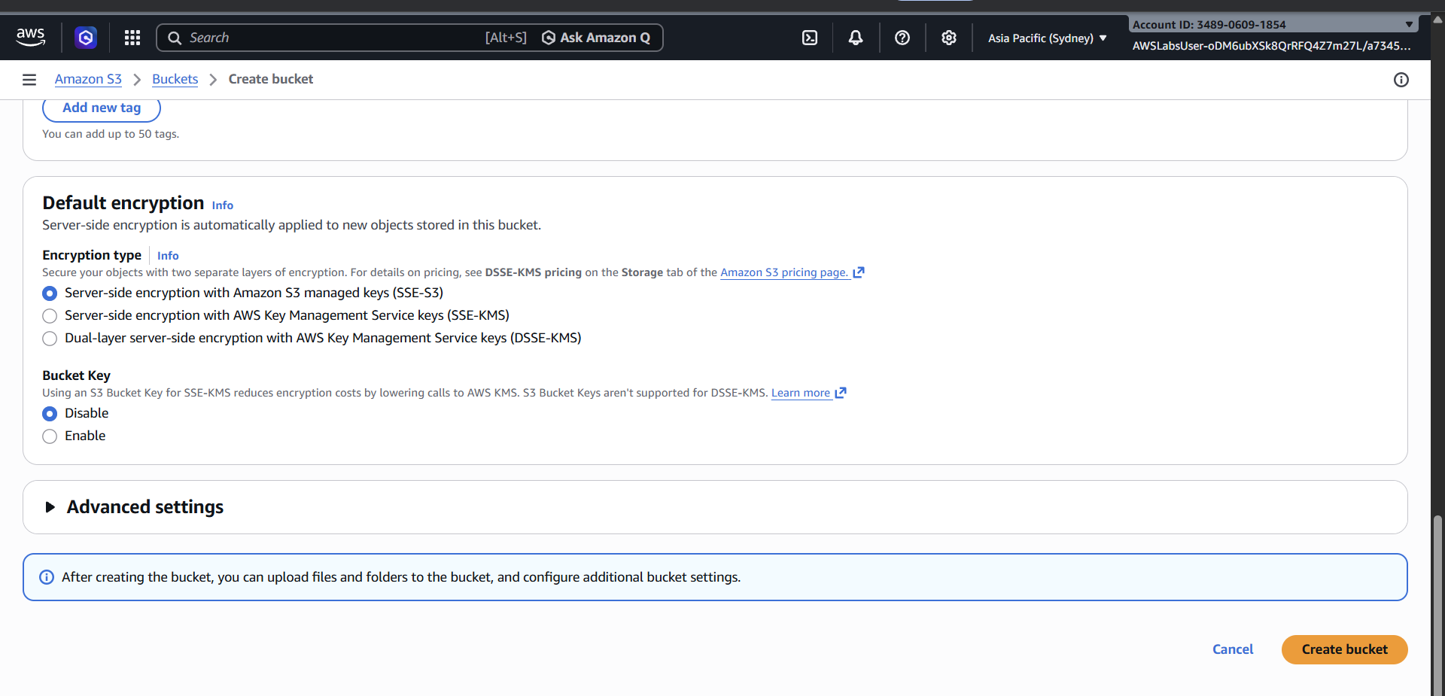

3. The Bucket’s Dashboard
After creating the bucket, open the bucket named war--500 in Amazon S3. You will be directed to its dashboard, where you can view and manage files, permissions, and settings of the bucket.
